A000-AM,C-Taino-Tripointer-Type I-Anthropomorphic-Porphyritic Rhyolite-Polished-1000 CE

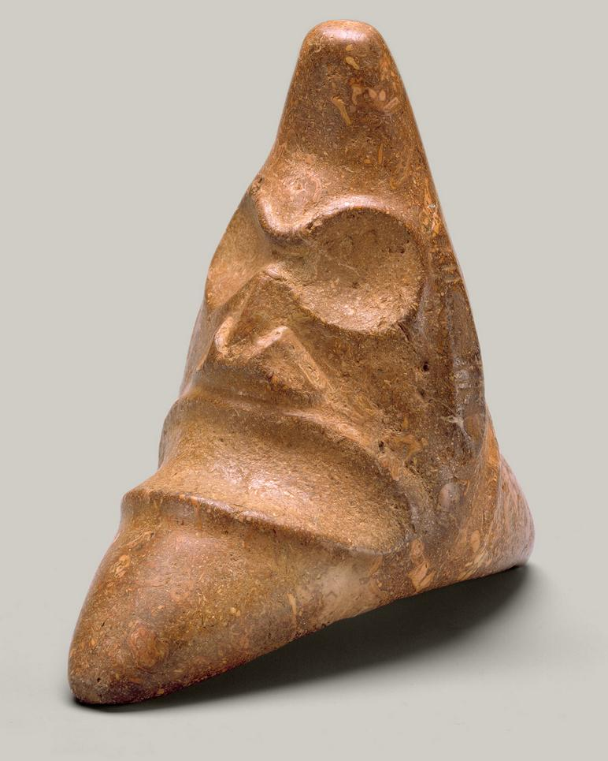

**Fig. 1.** AM,C-Taino-Tripointer-Type I-Anthropomorphic-Porphyritic Rhyolite-Polished-1000 CE

Case No.: 18

**Accession No.**

**Formal Label:** AM,C-Taino-Tripointer-Type I-Anthropomorphic-Porphyritic Rhyolite-Polished-1000 CE

**Display Description:**

The Taino people produced three-cornered stones, known as *trigonolitos*, over a broad expanse of time that allowed for evolution of their form. Early examples are small in size and believed to have been privately owned, while later larger sculptures may have been used in public ceremony. *Trigonolitos* are known in plain and decorated examples, and, as they are concave on the bottom, many do not sit comfortably on a flat surface. This is because they were meant to be affixed to a Taino Yuke (or Yoke), a circular donut-shaped band of basalt that was awarded to the captain of the winning ballgame contest.

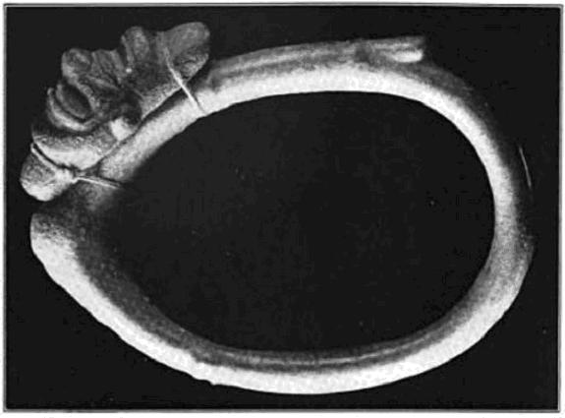

Fig. 2. Basalt Yuke (or Yoke) showing method of attachment of a grooved three-pointed stone. Collar, 16.5 in. dia. (after Fewkes (1907: Plate LXIXa).

A prevalent image among them is that of this compelling face, with large, sunken eye sockets and a wide, toothless mouth. The grimacing face has a skeletal aspect, an imposing quality often found in Taino art. This example bears a pattern of concentric circles on its opposite side, that represents the power of the Sun deity or Yaya. It was reportedly found in the Dominican Republic, probably part of one of the major Taino chiefdoms at the end of the fifteenth century. Taino imagery of the Tripointers or *trigonolitos*. are depictions of mediating spirits that intercede with the ineffable.

**LC Classification: F1909**

**Date or Time Horizon: 1000 CE**

**Geographical Area: Caribbean**

**Map:**

**GPS coordinates:**

**Cultural Affiliation:**

**Medium: porphyritic Rhyolite**

**Dimensions:**

**Weight:**

**Condition: original**

**Provenance:**

**Discussion:**

**References:**

Fatima Bercht; Ricardo E Alegría. 1998. *Taino: Pre-Colombian Art and Culture from the Caribbean*. Museo del Barrio: New York, NY, p.

# Roberts, Larry; Josh Roberts; Richard Rossetto. [2014] *Taíno sculpture: art of the gods*. Micanopy, FL : Signature Book Printing, p. 70, fig. 110.